February 2023
Dear Pharmacy Contractor
Re: Notice of a Special Meeting of Contractors to amend the LPC Constitution
Proposals to update the LPC model constitution and in parallel for contractors to consider the future size and footprint of their LPC(s) were made by the Review Steering Group (RSG) and supported by an overwhelming majority of community pharmacy contractors in a national vote in June 2022.

PSNC has drafted a new model constitution for Local Pharmaceutical Committees (LPCs), which Devon LPC recommends to you. I attach a pack consisting of the existing LPC constitution, the proposed amended constitution and a guide explaining the main changes, including what it means for contractors in Devon. This includes a recommendation to retain our existing LPC area. This information is also available on our website, click here. (https://devonlpc.org/about-us/your-lpc/transforming-pharmacy-representation-tapr-programme/)

We are required to seek your approval by ballot of pharmacy contractors to proceed with all our local changes in their totality. You are entitled to cast one vote for each of the pharmacy contractor premises you have in the Devon LPC area. You can vote in one of two ways: we recommend you vote using the voting form sent with this pack. Votes cast by email must be received by 5pm on Friday 3rd March 2023.

Alternatively, you can vote by attending our special general meeting. You will need to register in advance for the meeting; once you register the joining instructions will be sent to you nearer the meeting.

This special general meeting will take place using Zoom at 7.30pm on Monday 6th March 2023 and I have enclosed a copy of the agenda.

I do hope you are available to join us for the special meeting.
If you are unable to attend the meeting, I have attached a form to allow you to register your vote by email or post. Votes cast by these methods must be received by 5pm on Friday 3rd March 2023
We need your support to make sure that we can continue to represent you equitability and effectively and to ensure that we continue to have the best team working on your behalf. Please say yes to the changes we have proposed.

Please note you must be the pharmacy owner or authorised by them to cast your vote (this email can be forwarded on).

Yours Sincerely,
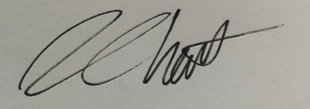
Andrew Howitt
Chair of Devon LPC

