List of pharmacies participating in the Specialist Medicine Service
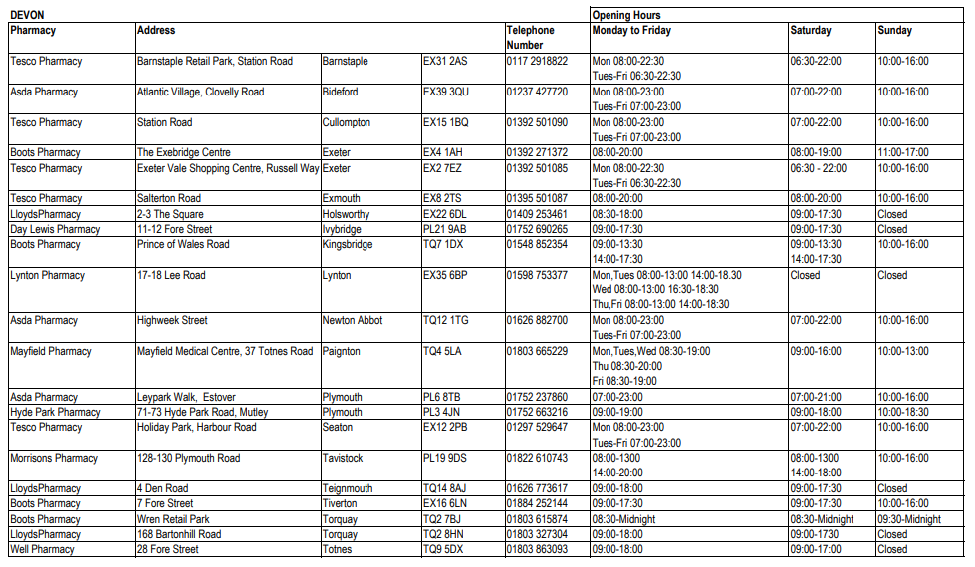
Hospiscare - East Devon, Mid Devon and Exeter https://www.hospiscare.co.uk/
Telephone: 01392 688000 (8am – 5pm, seven days a week)
If you need out of hours support, call 01392 688044. This line is open seven days a week, 5pm to 8am. We’re here to support our patients and their family members or carers. You can also use this number if you’re a healthcare professional in need of urgent specialist palliative care advice, even if it’s not on behalf of one of our patients.
Rowcroft Hospice – Torbay and South Devon https://rowcrofthospice.org.uk/
Telephone: 01803 210811 (Monday to Friday 9am – 5pm), 01803 210812 (Weekends and Bank Holidays 9am – 5pm), General advice outside these hours 01803 210800
North Devon Hospice – North Devon https://www.northdevonhospice.org.uk/
Telephone: 01271 344248
North Devon Hospice has an advice line for healthcare professionals who are providing palliative care to local patients. This line is available 24/7: 01271 347214
St Lukes Hospice – Plymouth, Tavistock and West Devon https://www.stlukes-hospice.org.uk/
Telephone: General Enquiries 01752 401172
St Luke’s at Home and Urgent Care Service 01752 964200 (for out of hours support 01752 401172 5pm to 9am)

NHS - The NHS website - NHS (www.nhs.uk) Enter ‘end of life care’ in search box to find the list of resources
Hospice UK - http://www.hospiceuk.org/

Devon Carers - https://devoncarers.org.uk/
Carers UK – https://www.carersuk.org
Marie Curie - Care and support through terminal illness | Marie Curie List of useful organisations (mariecurie.org.uk)

