Monday 19th September 2022
Bank Holiday Opening Hours

This pharmacy will open the following hours over the Bank Holiday:

Monday 19th September 2022

Please be aware that, due to limited staff on bank holidays, waiting times may be longer or some services restricted. Thank you for your understanding and patience while we serve you.

The following pharmacies in this locality are opening over the Bank Holiday (please telephone ahead to check):

Date | Times | Pharmacy Name | Address | Postcode | Tel Number

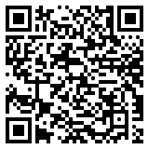
Local pharmacy details
can also be found by
scanning this code or
by visiting www.nhs.uk

Worried you have an urgent medical concern? Call 111 or visit 111.nhs.uk.
NHS 111 is available 24 hours a day, 365 days a year.
Calls are free from landlines and mobile phones.

