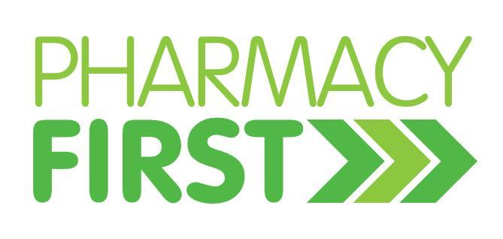
Before you book a GP appointment, have you considered your…

For NHS help with:
- Urinary Tract Infections (For women aged 18 – 64)
- Impetigo
- Nappy Rash

And non-NHS treatment for:
- Coughs & Colds - Hayfever & Allergies
- Constipation - Emergency Contraception
- Diarrhoea - Indigestion & Reflux
- Dry skin & Rashes - Sore Throat
- Earwax - Thrush
- Headaches - And much more…

