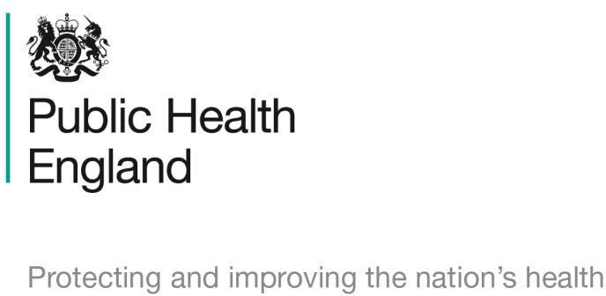

**Mandatory Seasonal Flu Campaign 2020 – tally sheet**

|  |  |  |
| --- | --- | --- |
| **Criteria** | **Number of interventions –**  **5th October 2020 to 3rd November 2020** | **Total** |
| Example |  | 15 |
| Total conversations regarding the flu campaign? |  |  |
| Flu campaign conversations during  MUR or NMS consultations? |  |  |
| Customers referred to GP/ED/other healthcare professional due to  flu campaign? |  |  |

Thank you for your support during this pharmacy contract campaign and for making a positive impact on the health and wellbeing of your local population. We will be producing evaluations for each campaign and will ensure you receive regular updates on the impact of the campaigns.