Pomona House
Oak View Close
Torquay, TQ2 7FF
www.devonccg.nhs.uk
Friday 25 September 2020

Sent via email

Dear pharmacy colleagues,

I am writing to thank you and your community pharmacy teams for your continued exceptional efforts during the COVID-19 pandemic response.

I could not be prouder of how you and your teams have come together to work professionally, flexibly and enthusiastically – your resilience in the face of unprecedented prescription demand and the support for your local communities.

I would like to take this opportunity to mark World Pharmacist Day today. While we don’t directly commission community pharmacy here at the CCG, I know this is a vital role in primary care services and that pharmacists are important members of multi-disciplinary teams. To mark World Pharmacist Day, we are raising the profile of pharmacy careers, and have worked with Devon’s Proud to Care recruitment team to feature this important role to the Proud to Care website. The aim is to increase the number of people applying to study pharmacy in Devon.

COVID-19 has meant huge changes to the way we work and this will continue for some time, but your dedication, courage and willingness to go above and beyond – often at great personal cost – has been immense.

While this will go down as one of the most challenging periods in the history of health and care, we have, as a system, done our bit to keep the people of Devon safe.

The months ahead are likely to continue to be challenging, so we mustn’t get complacent, but I am confident that, with your help, we will continue to rise to the challenges we face.

Keep up the good work and stay safe.

Best wishes.

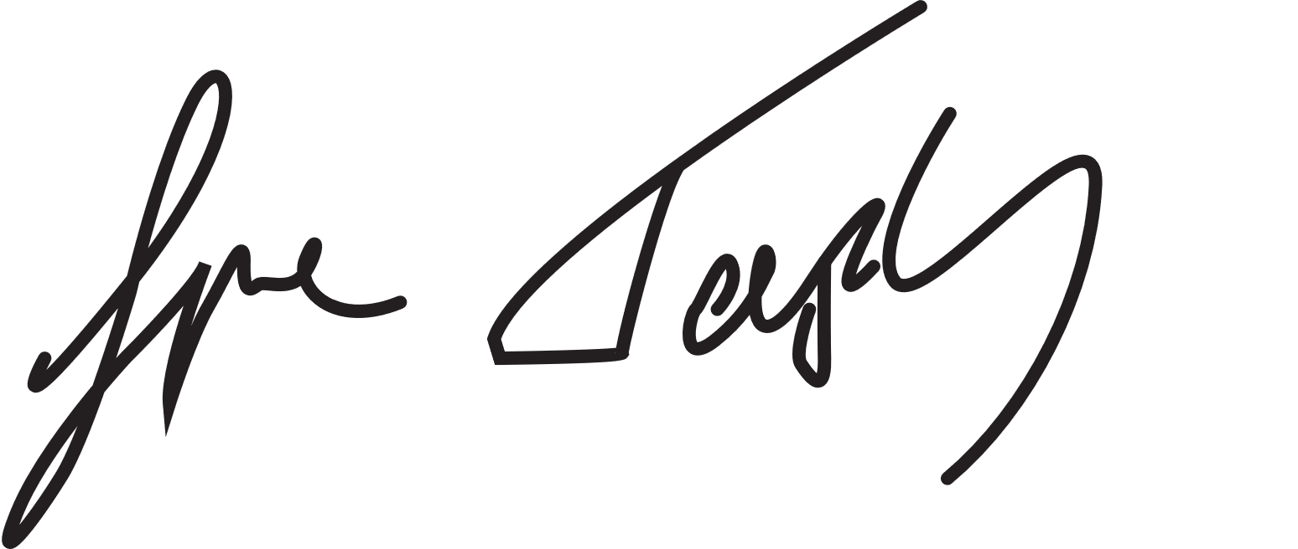

Simon Tapley
Accountable officer
NHS Devon Clinical Commissioning Group

