How to access - A Directory of Services Account for RAG
CPCS Pharmacy Emergency Short Notice Closure Reporting

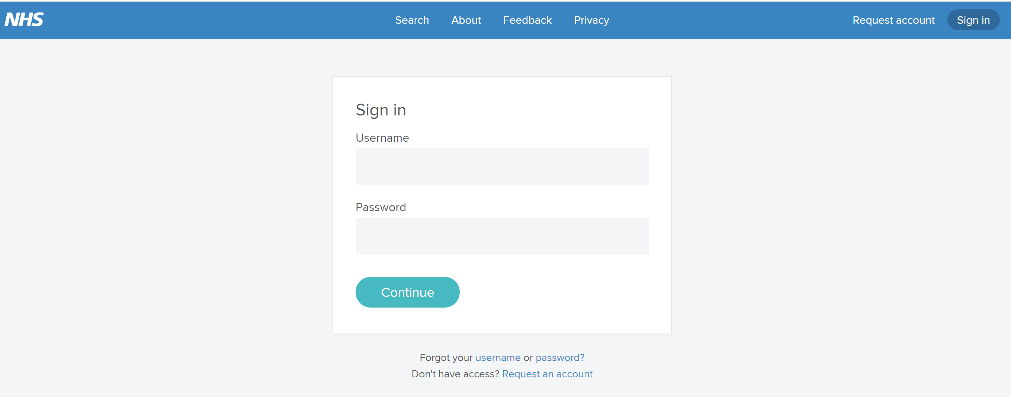
Step 1 - Go to https://www.directoryofservices.nhs.uk

Only click on Request an Account

Step 2 - The next screen you will see will be that of the Request Account template. Because you are applying for a generic account for a particular reason (RAG) for your Pharmacy, this needs to have a set of precise information.
Detailed format required, please could you apply your specific information in the same way when applying for your Pharmacy account.

Click Request account and you will now see this message: -

New user account raised successfully. Please check your emails and visit the verification link provided.

Step 3 - You will receive within a few minutes an automated email in your generic email box.
Please open this email and click on the link provided to verify your account

You will now see this message: -
This account is now pending approval from your administrator. You will receive a further email once approved. Please note you will not see your service until approval has been granted.

Step 4 – Once you have confirmation of your account approval - Please follow the ‘How to use RAG’ Guidance for all Emergency short notice closures. The terms of which are within your CPCS contract specification.

1/12/2019.v1

