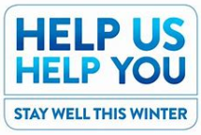
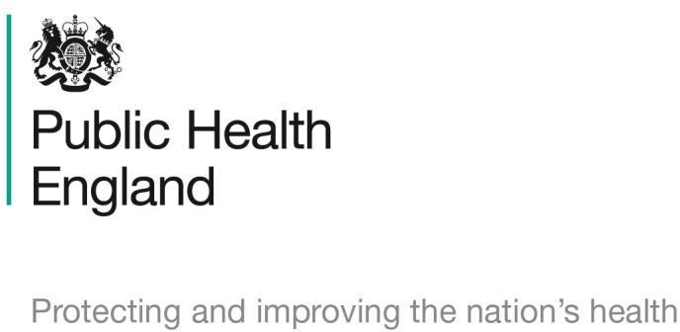
HUHY Stay Well This Winter campaign – tally sheet

Criteria | Number of interventions –  from 11.111.2019 to 31.12.2019.  (Evaluation due on PharmO between 01.01.2020 and 15.01.2020 2019) | Total
Example |  | 15
Total conversations regarding the
campaign?
Campaign conversations during
MUR or NMS consultations?
Customers referred to GP due to
campaign?

Thank you for your support during this pharmacy contract campaign and for making a positive impact on the health and wellbeing of your local population. We will be producing evaluations for each campaign and will ensure you receive regular updates on the impact of the campaigns.

