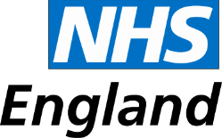
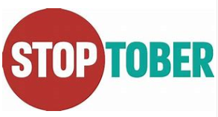
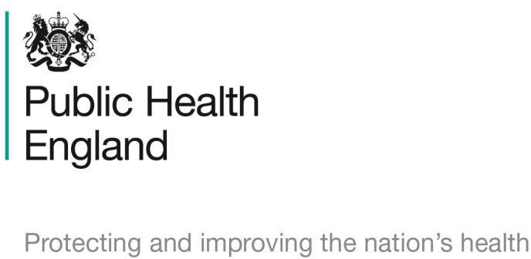
Stoptober campaign – tally sheet

Criteria | Number of interventions –  from Monday 1st October 2019 to Thursday 31st October 2019 | Total
Example |  | 15
Total conversations regarding the
campaign?
Campaign conversations during
MUR or NMS consultations?
Customers referred to GP due to
campaign?

Thank you for your support during this pharmacy contract campaign and for making a positive impact on the health and wellbeing of your local population. We will be producing evaluations for each campaign and will ensure you receive regular updates on the impact of the campaigns.

